DAA Practical Examination

Prashansha Sharma

180087

A2 Batch

OBJECTIVE: Write a program to sort n numbers using Merge Sort technique

i) Using normal approach i.e. recursion illustrating Divide and Conquer

CODE:

#include<stdio.h>

#include<conio.h>

#include<stdlib.h>

int a[10];

merge(int p,int q,int r)

{

int n1,n2,k,i,j;

n1=q-p+1;

n2=r-q;

int L[10];

int R[10];

for(i=1;i<=n1+1;i++)

{

L[i]=a[p+i-1];

L[n1+1]=20;

}

for(j=1;j<=n2+1;j++)

{

R[j]=a[q+j];

R[n2+1]=20;

}

i=1;

j=1;

for(k=p;k<=r;k++)

{

if(L[i]<=R[j])

{

a[k]=L[i];

i=i+1;

}

else

{

a[k]=R[j];

j=j+1;

}

}

printf("\n");

for(k=1;k<=r;k++)

{

printf("%d\t",a[k]);

}

getch();

}

merge_sort(int p,int r)

{

int q;

if(p<r)

{

q=(p+r)/2;

merge_sort(p,q);

merge_sort(q+1,r);

merge(p,q,r);

}

}

main()

{

int i,p,r,t;

printf("\n Enter the array size:");

scanf("%d",&t);

p=1;

r=t;

printf("\n Enter the integer values for array:");

for(i=1;i<=t;i++)

{

scanf("%d",&a[i]);

}

merge_sort(p,r);

getch();

}

OUTPUT:

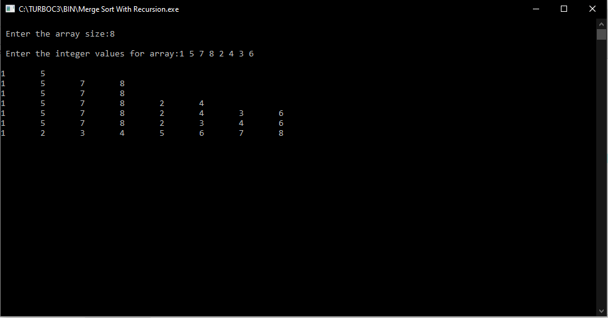

ii) Without using recursion

CODE:

#include<stdio.h>

#include<conio.h>

#include<stdlib.h>

int a[10];

int min(int x,int y)

{

return (x<y)?x:y;

}

merge(int l,int q,int r)

{

int n1,n2,i,j,k;

n1=q-l+1;

n2=r-q;

int L[10];

int R[10];

for(i=0;i<n1;i++)

{

L[i]=a[l+i];

}

for(j=0;j<n2;j++)

{

R[j]=a[q+1+j];

R[n2+1]=20;

}

i=0;

j=0;

k=l;

while(i<n1 && j<n2)

{

if(L[i]<=R[j])

{

a[k]=L[i];

i=i+1;

}

else

{

a[k]=R[j];

j=j+1;

}

k++;

}

while(i<n1)

{

a[k]=L[i];

i++;

k++;

}

while(j<n2)

{

a[k]=R[j];

j++;

k++;

}

}

merge_sort(int n)

{

int q,s,li,ri;

for(s=1;s<n-1;s=2*s)

{

for(li=0;li<n-1;li+=2*s)

{

q=min(li+s-1,n-1);

ri=min(li+2*s-1,n-1);

merge(li,q,ri);

}

}

}

main()

{

int i,p,r,n;

printf("\n Enter the array size:");

scanf("%d",&n);

printf("\n Enter the integer values for array:");

for(i=1;i<=n;i++)

{

scanf("%d",&a[i]);

}

merge_sort(n);

printf("\n");

for(i=1;i<=n;i++)

{

printf("%d\t",a[i]);

}

getch();

}

OUTPUT:

